EDTC 812

Teaching in the Adult Learning Environment

Dr. Amerman

Summer 2019

Assessment 1: Corporate Training

Monsanto – Using Company Technologies Appropriately

Terri Evans

Patrick Holness

Manuel Negron

Denise Tate

**Executive Summary**

**Who We Are**

Maverick International Business Training (MIBT) has been providing professional training across the globe since 1995 and is committed to delivering first-rate services to a wide variety of businesses, from small entities to corporations.

**Problem**

Monsanto’s foundation is built on integrity. It is with distinction that their representatives’ security, operable communities, clients, buyers, and ecosystems are held in the highest regards (Monsanto Code, 2013, p. iii). The company plays a crucial role in sustainable agriculture and any measures to devalue improving lives on a global scale critically threatens that foundation and jeopardizes the mission to make the world a better place in which we must live.

With the latest growth of the company, Monsanto has procured a mass of newly recruited employees to reinforce its mission in supporting farmers in emerging nations. The new staff located in remote places worldwide will need to be well informed of Monsanto’s policy for aptly utilizing technology. “When it comes to our Company’s technology, we have a responsibility to use these assets appropriately, ethically, in a safe and secure manner and within the law” (p. 14). It is difficult to envision all avenues that individuals can impair, interrupt, or abuse Monsanto’s technological resources. Such acts have the potential to jeopardize the integrity and stability of the company. Therefore, effective online training on the appropriate use of Monsanto’s technologies will be provided to ensure company compliance is acknowledged and maintained.

**Timeline and Training**

In order to prepare constituents properly and efficiently, a dedicated schedule of training will be executed as follows: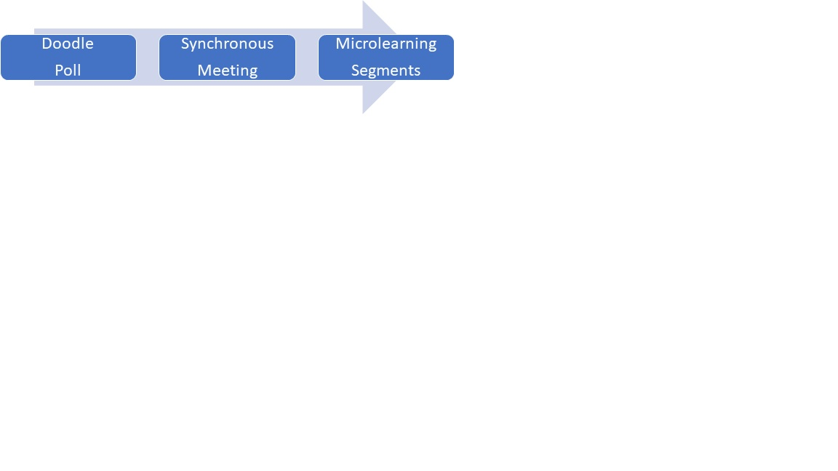

As a segment of orientation, employees will receive a Doodle poll for available times to attend a synchronous online meeting. A Doodle poll is an online site utilized to efficiently determine a date and time for a multitude of individuals to meet (“What is Doodle,” n.d.). This census will be emailed, giving participants five days to respond. Once the dates are selected, participants will be informed with subsequent reminders via Google Calendar or Microsoft Outlook. Two live sessions (identical) will be offered the following week to accommodate individual schedules. The synchronous meeting lasts sixty minutes as a standard and is led by our IT expert to explain technologies, which Monsanto will make available. Within that time period, the presenter will provide interactive demos to get the new employees acclimated to the technology. A question and answer session will follow if necessary.

To keep employees reminiscent of technology appropriation, microlearning will be executed in quick bite videos and in a geofencing mobile application. Srivastava and Sheshadri (2013) define geofencing as “a virtual perimeter on a geographic area established in connection with a suitable location-based service” (p. 9). Notifications are sent to designated mobile devices to receive information.

**Training Agenda**

The agenda for synchronous training on the use of company technology will include an introduction to company systems and instruction on system use including access, availability, authorization and general expectations for conduct. An overview of the Human Resources system, email system and the company policy that lawfully allows them to monitor system activity will be presented. To create an environment that is interactive, the chat box will be used to provide opportunities for discussion (Fleming, 2010).

The facilitator will provide a synopsis of the company email system including a demonstration of best practices for email setup on the desktop and on mobile devices. Procedures for archiving will also be addressed. As this system will require regularly scheduled password changes, employees will be advised against using the same password across all systems. Use of a passphrase will be suggested so passwords can be created that are easy to remember.

A presentation and practice of the appropriate use of social media will be included. A clear distinction will be made between what is and is not appropriate. Examples of acceptable use will be demonstrated in the form of real-life scenarios. These situations will be presented in the session giving attendees an opportunity to reflect on the action they would take if the situation presented itself. The training will also address information security, protection of data, and phishing. Emphasis will be placed on using a passphrase to facilitate strong passwords, backup and data protection and how to recognize phishing in email messages. Information is repeated during this training intentionally to reinforce its importance.

Microlearning segments offer an opportunity for individual accountability as they are delivered to the employee directly. The segments will provide a quick refresher and a quick assessment to evaluate familiarity with company systems and related policies, procedures, and expectations. Eighty percent accuracy is expected in each of the four areas. Once accountability has been achieved with microlearning segments in each area, the system cease to send microlearning segments to the employees.

**Monsanto Online Synchronous Systems Training**

1. Appropriate Use of Technology
   1. HR Systems: personal information updates and payroll changes
   2. Email systems: desktop and mobile devices
   3. Social Media: images and information
   4. Information Security: strong passwords and recognizing phishing
2. Microlearning segments
   1. Brief scenarios presented to employees for them to identify
      1. Email phishing
      2. Strong passwords
      3. Social media posts
      4. Protecting data

**Training Activities**

**Human Resources System Activity.** Copy and paste the shared link for the email system in a browser window, sign on and enter the name and password. Change the password using the instructions and suggestions in the training. The facilitator and an assistant will be available so each can address questions or concerns that are delivered through the chat box.

**Email System Activity.** Attendees will be presented with four real-life scenarios. Each scenario will present an opportunity for a response via the chat box to assess email messages and whether or not they are safe to respond to. After each example, the facilitator will deconstruct the message.

**Social Media Activity:** Attendees will be presented with four real-life scenarios. Each scenario will present an opportunity for a response via the chat box to assess actions in line with the policy or not. After each example, the facilitator will deconstruct the scenarios.

**Information Security Activity:** Attendees will be presented with 4 real-life scenarios. Each scenario will offer an opportunity to determine the password’s strength and state why in the chat box.

**Microlearning Segments:** Microlearning segments will present information similar to those presented in the first session. Employees will demonstrate mastery by doing (i.e. making a weak password strong or correcting a potentially harmful social media post).

**Formative and Summative Assessments**

Maverick International Business Training is committed to the delivery of quality professional training. We recognize the importance of training evaluation. This notion is predicated on extensive literature that exists in training evaluation methods. Training is an accepted practice in the transformation of the workplace (Pidd, 2004). We want Monsanto to view training as an investment and not an expense. MIBT uses formative and summative assessments throughout the delivery of content. Our approach is grounded in a systems approach that integrates Kirkpatrick’s (KP) and Stufflebeam (CIPP) models. MIBT is focused on looking at the entire organization to ensure that Monsanto’s commitment to integrity is maintained within its operations.

Formative assessments are integrated within the learner experience. Facilitators will monitor and assess participants in each of the learning modules. Participant’s ability to successfully set-up their email will satisfy that the learning objective was attained. Given the interactive nature of the training, participants will be required to apply their knowledge during the real-life scenarios where the facilitator can collect data on individual participants. Formative assessments allow the facilitator to monitor participant learning while also providing real-time clarification and adjustment in content if necessary. This data is captured in an engaging low-stakes interactive way. MIBT views formative assessments as an essential key in the process of organizational learning.

Summative evaluations are vital in ensuring that the learning outcomes were attained for both the facilitator and the participant. Participants will be given a customized web-based assessment designed by MIBT at the close of training with a timeframe for completion. Successful completion is attained only after receiving a score of 80% or higher on the identified learning modules. This final assessment does not mark the end; however, it is used as a marker of the results. MIBT’s training evaluation begins with Context (training criteria), Reaction Primary Evaluation (participant satisfaction), Learning Secondary Stage Evaluation (what did you learn?), Behavior Tertiary (change in behavior), and Results Later Evaluation (transfer of training) (Khalid, 2012). Evaluation is found throughout this process, ensuring that the learning goals for training were met, and there is evidence of attainment; as a result, employee behavior. In this case, we would expect that there should be low to no incidences with employees’ inappropriate use of technology-based on employee reviews or evaluations.

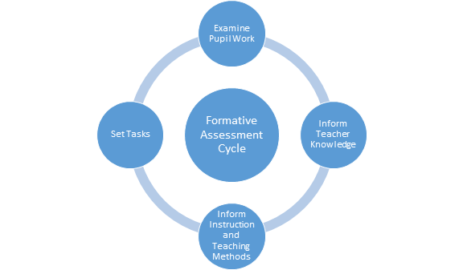

**Fees**

Monsanto recruited new employees to support farmers in emerging nations located in remote places worldwide. Due to the remote locations, training of the new employees needs to be strategic to assure that all employees receive the proper training. Effectively trained employees are a key component to the success of a company.

The Training Industry Report states that the average training cost per employee in 2016 was $1,041 and average-training budgets for small companies was approximately $234,850 annually. The Monsanto Company is a very large company that has many locations throughout the world. Therefore, when creating the company’s training budget, internal resources, software, and hardware must be taken into consideration to assure that they are cost effective and that the majority of the overall budget is not allocated solely towards training.

Since the synchronous training meetings are facilitated by the company’s IT expert, money does not have to be allocated for salary or to hire external training sources. In order to create the training budget, a needs assessment has been conducted, which has identified the following costs:

* 10.5-inch iPad Air Wi‑Fi 256GB - Space Gray - $636.00 (One--Time)
* AppleCare+ for iPad, iPad Air, or iPad mini - $62.00 (Every 2 years)
* Verizon Jetpack® MiFi® 8800L - $199.99 (Two Year Contract) (One-Time)
* Total Mobile Protection - $12.00 per month
* Unlimited Data Plan (4GLTE) - $80.00 per month
* Trainer - $0

According to these costs, the company would have a one-time fee of $866.00 per device to include the mobile hot-spot, insurance on both devices, and one month of unlimited data. Once the devices are purchased, it would cost the company $1043.00 annually for the unlimited data plan and the insurance protection plans. This approach would be the most cost effective for the company to assure that the new employees are getting an effective training in remote locations. The cost can be even lower because one mobile hotspot can connect up to five devices. Therefore, there is no need to buy one for each iPad.

Because the Monsanto Company is a sizeable company, the costs identified are very reasonable since the average training cost per employee in 2016 was $1,041, and we have identified the annual cost to be $1043.00 after the one-time purchase $866. The consideration that needs to be made is the number of devices necessary for each location to get a more detailed breakdown of the initial expenditure and the annual costs. Investing in a company’s training program has many benefits and determines the success of a company.

**References**

Fleming, C., (2010). Brief guide for teaching adult learners. *Good Reads*. Retrieved from <https://www.goodreads.com/book/show/20468709-brief-guide-for-teaching-adult-learner>

IPad Air - Why iPad. (n.d.). *Apple.* Retrieved July 29, 2019, from https://www.apple.com/ipad-air/why-ipad/

Monsanto Code of Business Conduct. (2013). *Monsanto Technology LLC*. Retrieved from:

<https://monsanto.com/app/uploads/2017/05/code_of_conduct_english.pdf>

Pidd K (2004). The impact of workplace support and identity on training transfer. Int. J. Train. Dev., 8(4).

Srivastava, A. N., & Sheshadri, S. H. (2013). *Creating Geofence Assistance Information*.

Retrieved from: <https://patentimages.storage.googleapis.com/96/5e/24/9f198e6197b839/>

US20130310053A1.pdf

Trends 2019. (2019). Retrieved July 29, 2019, from <https://trainingindustry.com/trends-2019/>

Verizon Wireless: Plans. (n.d.). *Verizon*. Retrieved July 29, 2019, from

<https://www.verizonwireless.com/onedp/plans#/plans>

What is Doodle and how does it work: An Introduction. *Doodle*. Retrieved at:

[https://help.doodle.com/hc/en-us/articles/360012150113-What-is-Doodle-and-how-](https://help.doodle.com/hc/en-us/articles/360012150113-What-is-Doodle-and-how-does-it-work-an-introduction)

[does-it-work-an-introduction](https://help.doodle.com/hc/en-us/articles/360012150113-What-is-Doodle-and-how-does-it-work-an-introduction)